KB1 – ZTIAPL

ON&OFF

Description of the basic goals and functioning of the game

ON&OFF is a 2D platformer with an option to switch dimensions and with the help of this mechanic you need to overcome puzzles, platforms, walls etc. Switching will be functioning as follows: some platform will be available in an “ON” mode and other platforms in an “OFF” mode. If you are currently in an ON mode, collision will be turned on for the objects and platforms currently in that “dimension” and vice versa in OFF mode, where objects and platforms that were in ON mode won´t be available. The goal is to overcome obstacles and barriers through the use of switching the dimension and reaching the objective or finish line. On the way, you can collect some objects (ex.: stars) which will function as a high score. You won´t need to collect all of them to finish, but if you want to a higher score, you will need to reach even the less accessible objects.

Opis základných cieľov a fungovania hry

ON&OFF je 2D platformová hra s možnosťou prepínania “dimenzií” a pomocou tejto mechaniky prekonávať puzzle, platformy, steny a podobne. Prepínanie bude fungovať nasledovne: niektoré platformy budú dostupné v “ON” móde a iné platformy zase v “OFF” móde. Ak sa nachádzate v ON móde, kolízia bude zapnutá na predmety a platformy, ktoré majú byť v tej “dimenzii” a presne naopak v OFF móde, kde platformy a predmety ktoré mali zapnutú kolíziu v ON móde už nebudú. Cieľom bude prekonať prekážky pomocou prepínania medzi jednotlivými módmi a dostať sa do cieľa. Cestou zbierate “predmety” (napríklad hviezdičky), ktoré budú mať funkciu ako high score. Aj keď všetky nebude potrebné pozbierať, ak chcete vyššie skóre, bude potrebné získať aj ťažšie dostupné predmety.

Description of game controls

All you need is a keyboard to control the player. With the arrow keys you can move left or right, jump with the up arrow key or if you prefer, you can also use WASD to move and it functions the same, with D you move left, A right, W jump. For switching the dimensions, you´re gonna use the SPACE button. You can switch the dimensions at any time. Esc will bring you to the main menu.

Návrh ovládania hry

Všetko čo potrebujete pre kontrolu hráča je klávesnica. So šípkami sa môžete pohybovať do prava alebo do ľava a s hornou šípkou skáčete. Taktiež môžete použiť WASD klávesy, ktoré fungujú takisto. D pohyb do prava, A do ľava a s W skáčete. Aby ste mohli prepnúť dimenziu, použitie medzerník. Dimenziu môžete zmeniť kedykoľvek. Esc vás vráti do hlavného menu.

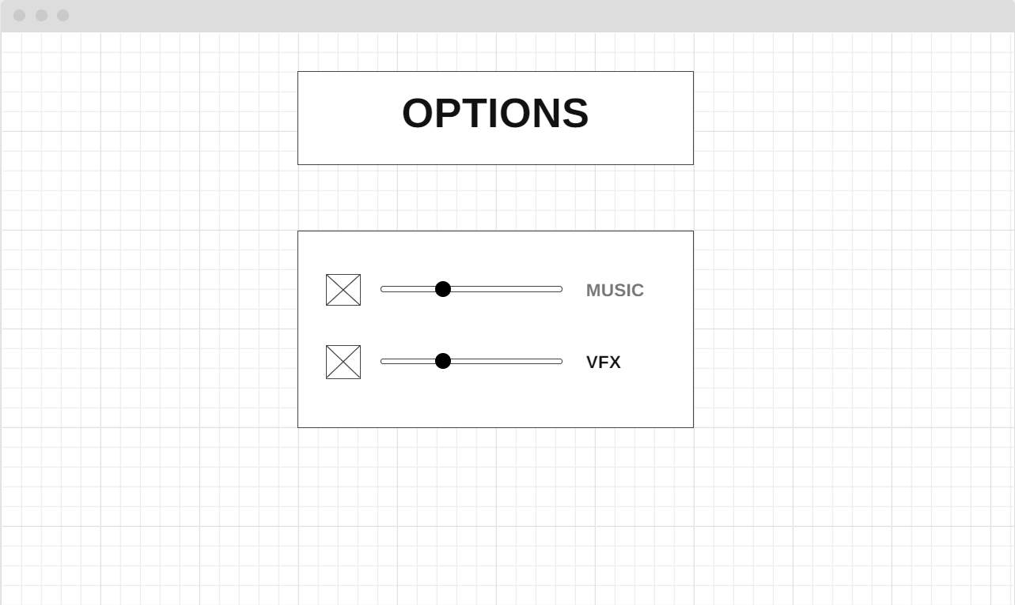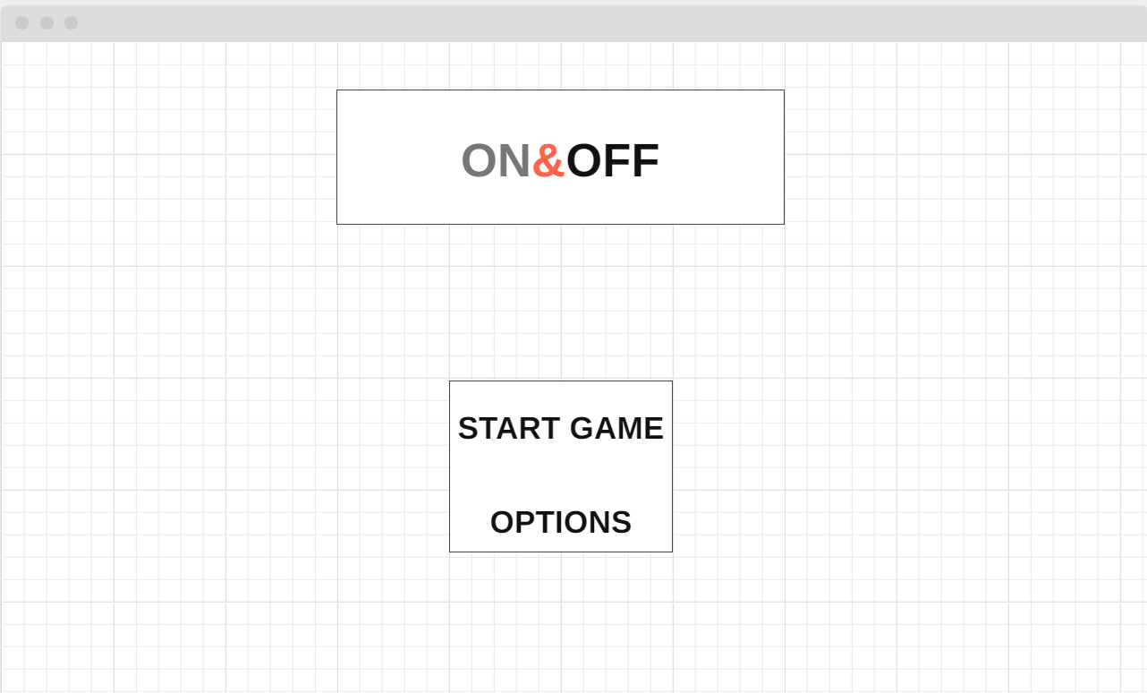

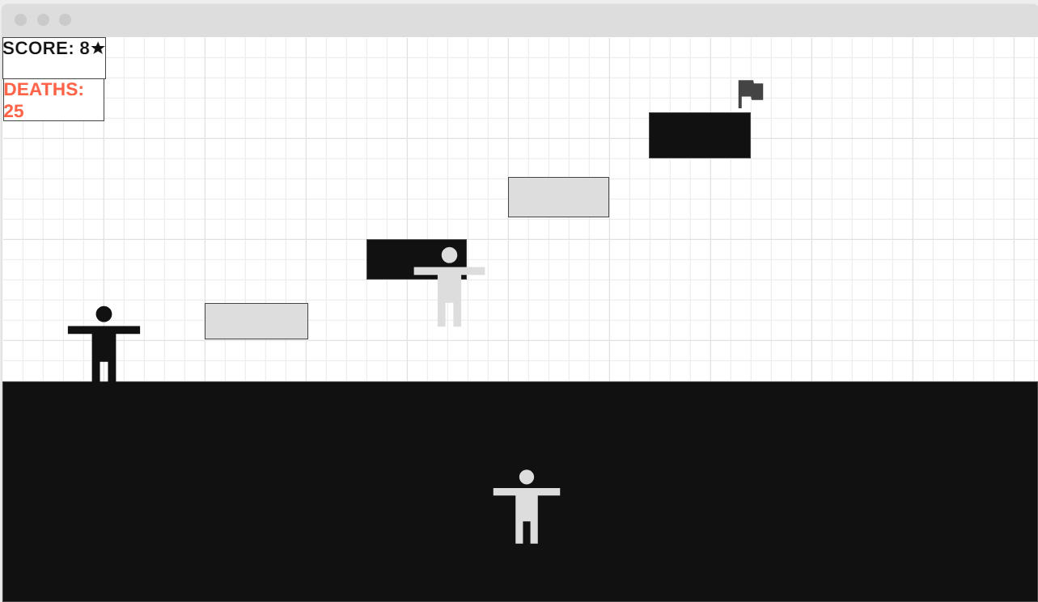

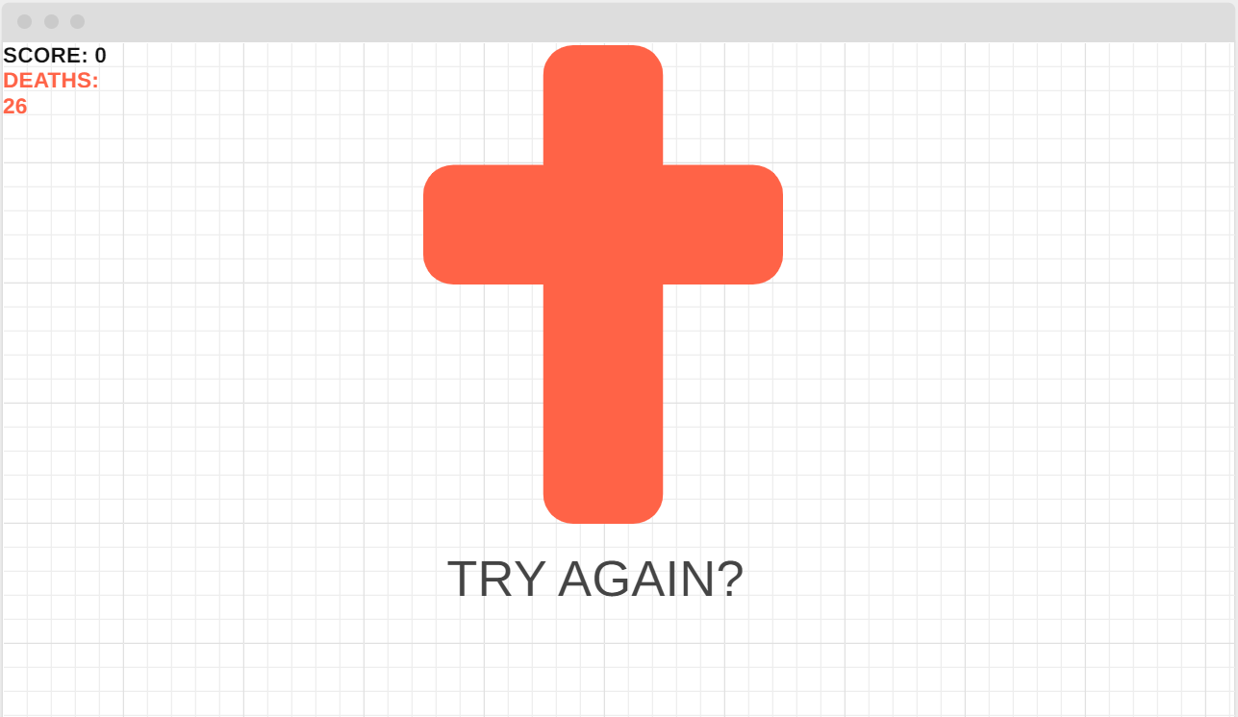

OOP description

* Class player
  + Direction
  + Speed
  + Form
    - Form.on
    - Form.off
    - Jump
    - Walk(direction)
    - Death
    - Collect
* Class collectibles
  + Position
  + Shape
  + Form
    - Collect
* Class platform
  + Position
  + Form(player)
    - Form.on
    - Form.off
* Class hud
  + Color
  + Shape
  + Position
  + Counter
    - Stars
    - Deathcounter

**Checkpoint 2**

*Sounds and music*

Some sounds will be made by me through FL studio 12 (some sounds are for reference, if I can make similar sound fx myself, I wont use these)

Jump sound – <https://opengameart.org/content/8-bit-jump-1>

Landing sound - <https://opengameart.org/content/jump-landing-sound>

Switching dimensions sound – air flowing <https://opengameart.org/content/100-cc0-sfx-2>

Collecting a soul sound – chime sound <https://opengameart.org/content/bell-dingschimes>

SOUNDTRACK

8-bit soundtrack made by me

*Art concepts*

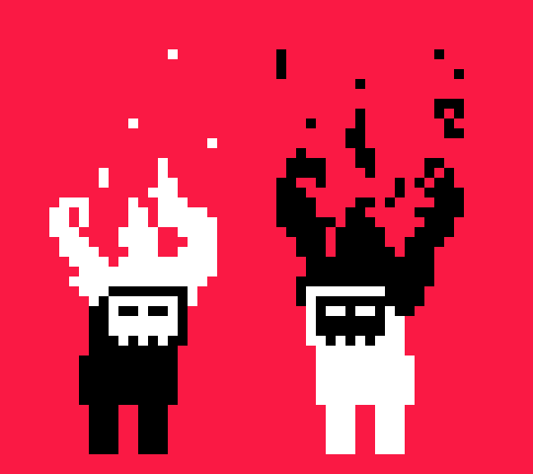

Main protagonist in both states – ON and OFF – with an animation of fire on top of his head

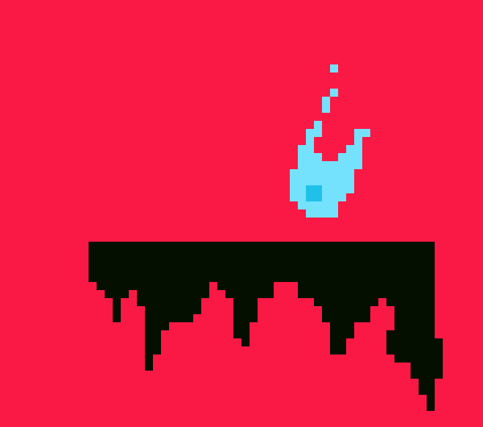

An example of a platform in an ON state with a collectible item – SOUL – on top of it. This will also hopefully feature an animation of soulfire

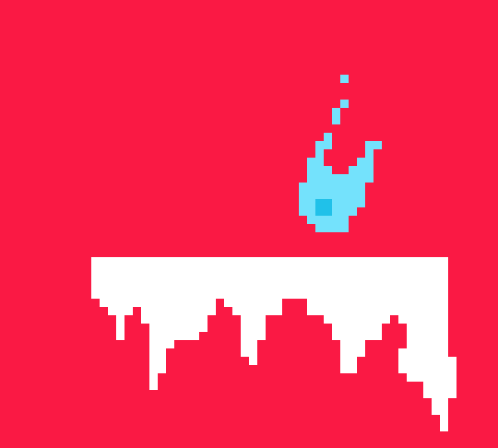

Platform in an OFF state – platforms will be same size but the stalactites will differ

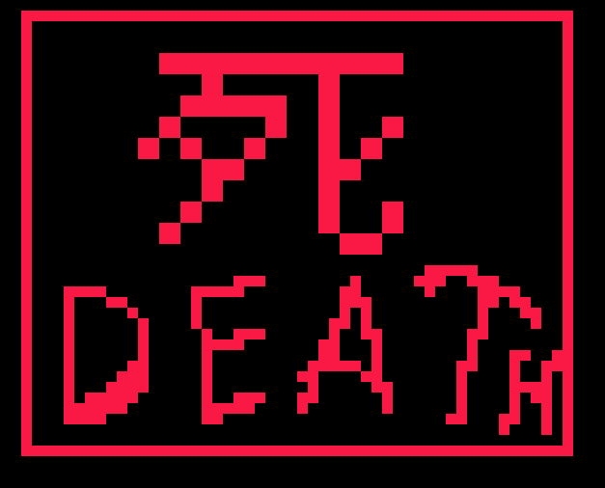

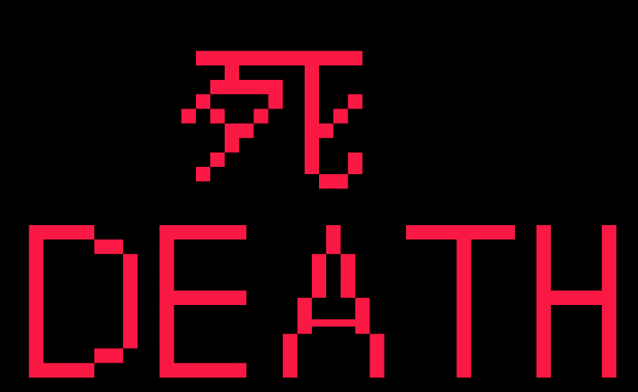

two variants of a death screen (when u fall of a platform or get stuck inside)

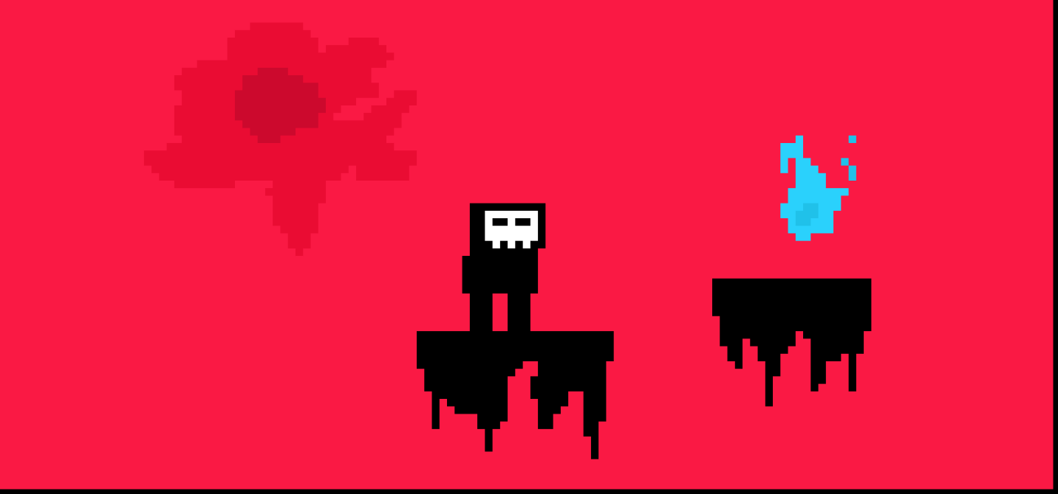

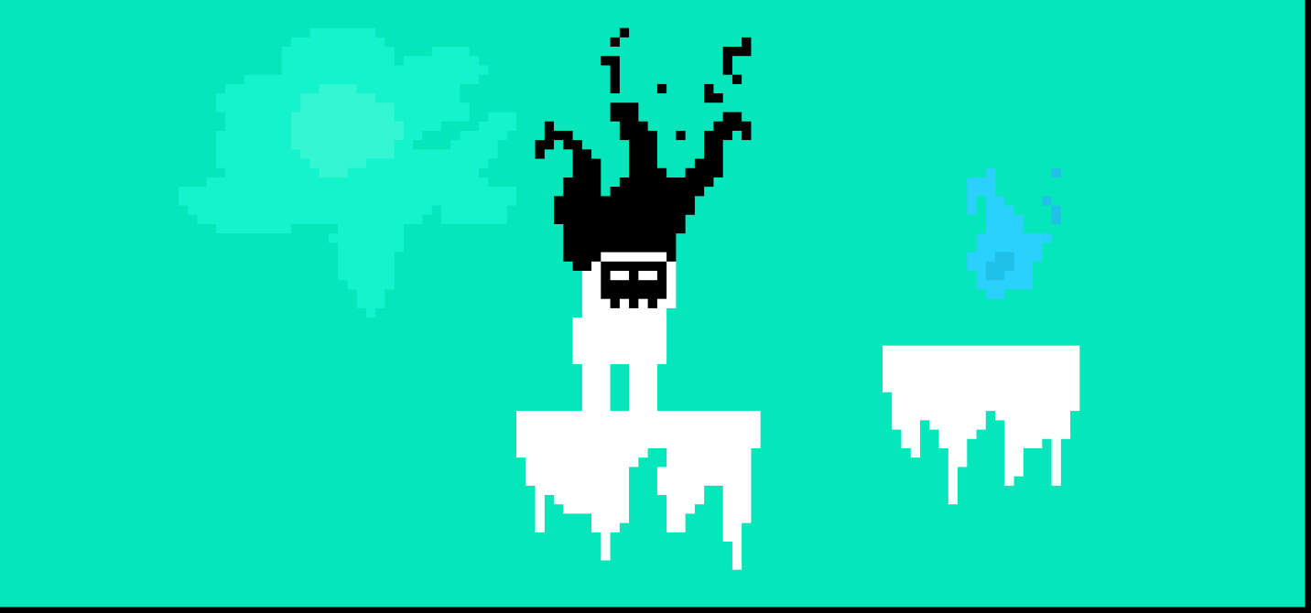Background_on

Background_off

*Colors:*

*background_on: #fa1944*

*sun_on / suncore_on: #ea0c33 / #cc092d*

*soulfire / soulcore: #2ad1fc / #20c1e9*

*background_off: #05e6bb*

*sun_off / suncore_off: #15f3cc / #33f6d2*